Exercise 6: Database Foundations
Week: 6 (Hands-On Laboratory Exercise)
Objective: To deploy a local MongoDB NoSQL database via Docker, integrate the native MongoDB driver into Node-RED, and upgrade the previously built HTTP APIs to perform Create, Read, Update, and Delete (CRUD) operations on persistent storage.

Step 1: Deploy MongoDB Locally via Docker
Before Node-RED can store data, we must spin up our database engine. We will use Docker to host a local instance of MongoDB, binding it to its default port.
- Pull the Image: Open the Docker Desktop and Search for the MongoDB image, and click the Pull button to download.
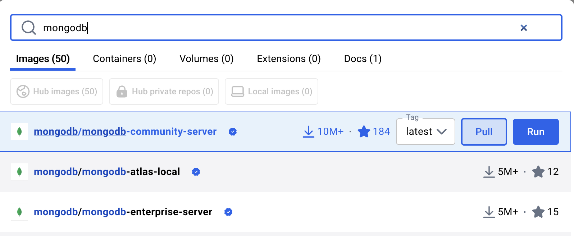
- Launch via Docker Desktop: Open your computer's Docker Desktop click the run button for the MongoDB image, and use the settings as follow:
  - Explanation: -p 27017:27017 maps the isolated container's default MongoDB port to your physical machine's Local Area Network.

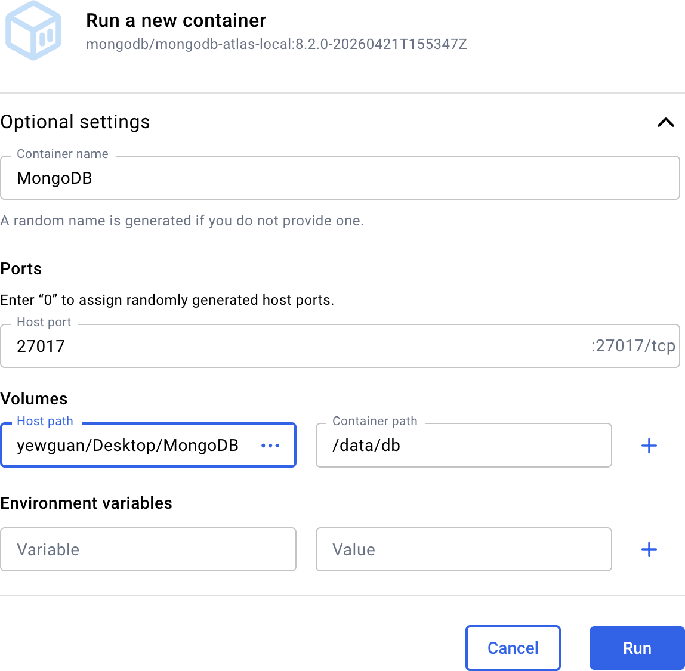

- Verify Execution: To verify your MongoDB docker is running, download and install the MongoDB Compass and enter the connection string:

mongodb://localhost:27017/?directConnection=true

- Then, click the Save & Connect button to view your database.

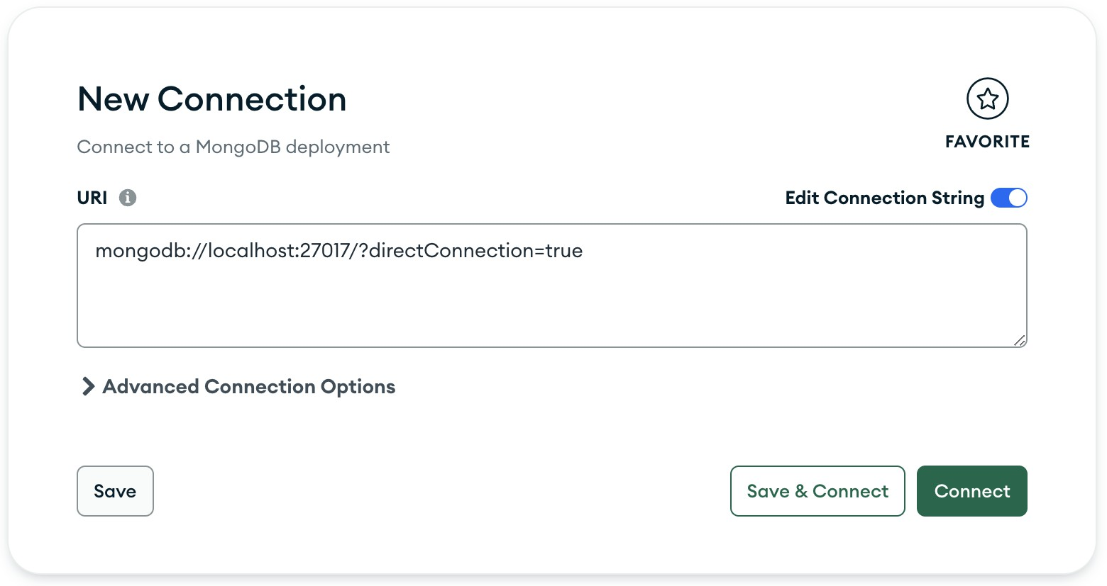

Step 2: Install MongoDB Nodes in Node-RED
By default, Node-RED does not know how to speak to MongoDB. We must install the official driver package to act as our database client.
- Open Node-RED: Navigate to http://localhost:1880 in your browser.
- Access the Palette Manager: Click the hamburger menu (three horizontal lines) in the top right corner and select Manage palette.
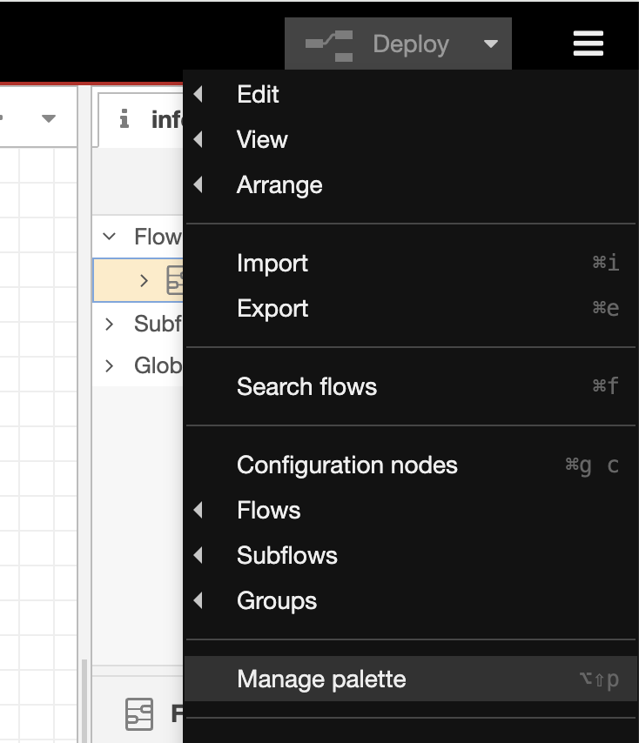

- Install the Driver: * Click the Install tab.
  - Search for node-red-contrib-mongodb4.
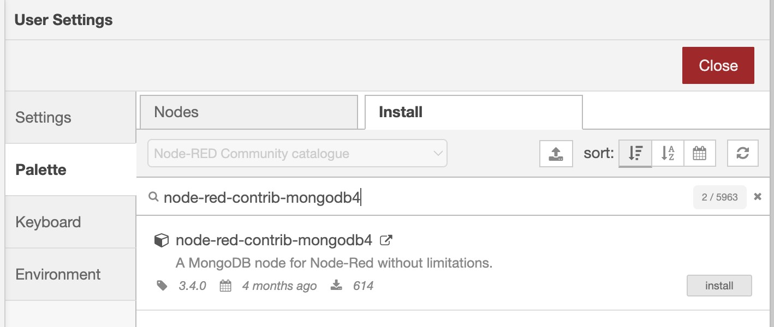

  - Click the install button and wait for the confirmation popup. You will now see new MongoDB nodes available in your left sidebar.
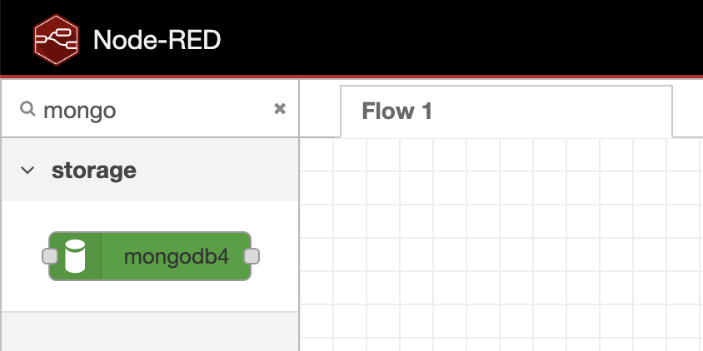

Step 3: Configure the Database Connection
We must now link our Node-RED middleware to our running database container.
- Add a MongoDB Node: Drag a mongodb4 node onto the workspace. Double-click it to open its configuration.
- Create the Server Connection: Click the pencil icon next to the "Connection" dropdown to add a new database server.
  - Connection URI: Type mongodb://host.docker.internal:27017/smart_campus?directConnection=true
  - (Note: Because both Node-RED and MongoDB are in separate Docker containers,
host.docker.internal tells Node-RED to route the traffic out of its container and back into the physical host machine's port).

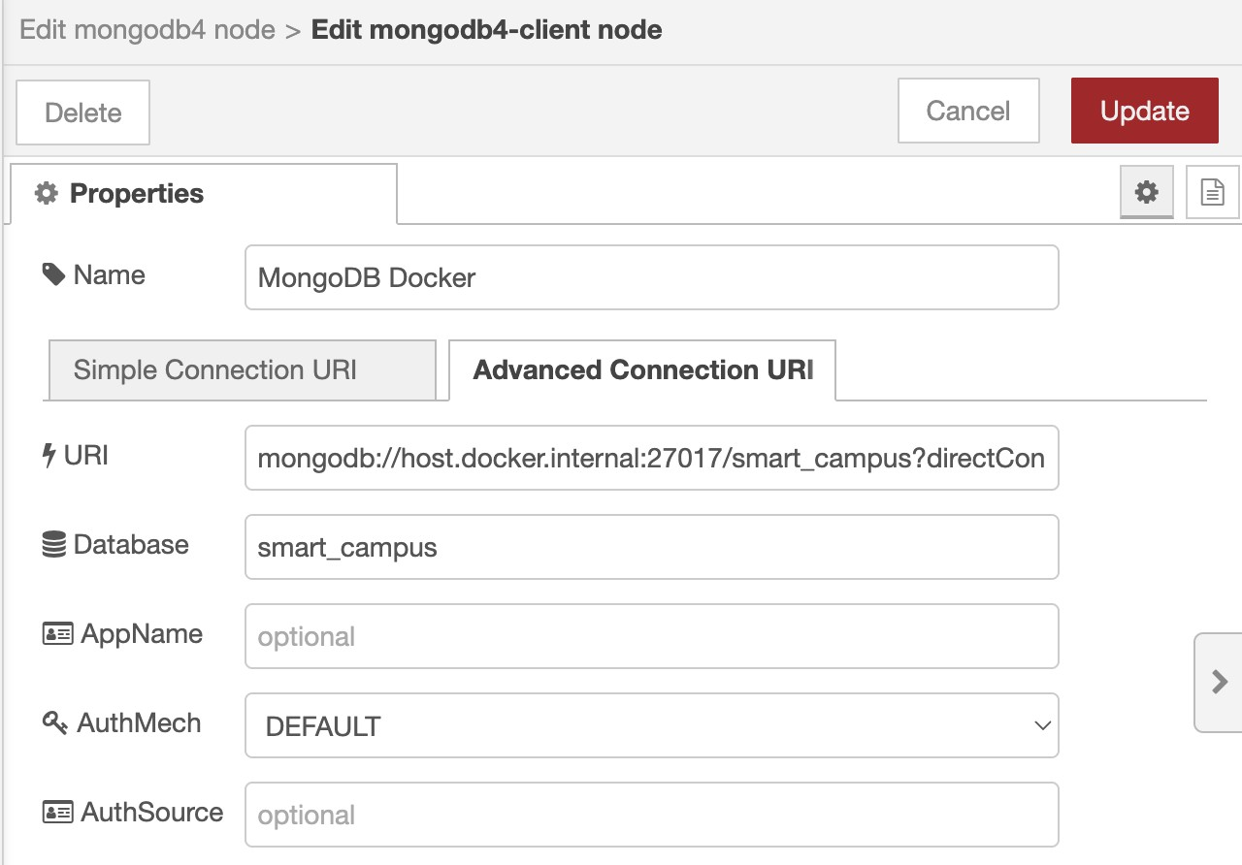

  - Click Add.
- Target the Database: Back in the node properties, set the following:
  - Database: smart_campus
  - Collection: sensor_data
  - Click Done. (MongoDB creates databases and collections dynamically; they will be generated automatically upon the first data insertion!)

Step 4: Upgrading REST APIs to execute CRUD Operations
We will now upgrade the endpoints you built in Week 4 to interact with persistent storage instead of just printing to the debug console.

Part A: CREATE (HTTP POST)

- Locate your existing http in node configured for POST /api/sensor.
- Delete the wire connecting it directly to the response and debug nodes.
- Wire the http in node into your configured mongodb4 node.
- Double-click the mongodb4 node and set the Operation to insertOne.
- Wire the output of the mongodb4 node to your http response node. Click Deploy.
- Test: Open Postman, send a JSON payload to your POST endpoint, and verify you get a 200 OK. The data is now permanently saved!

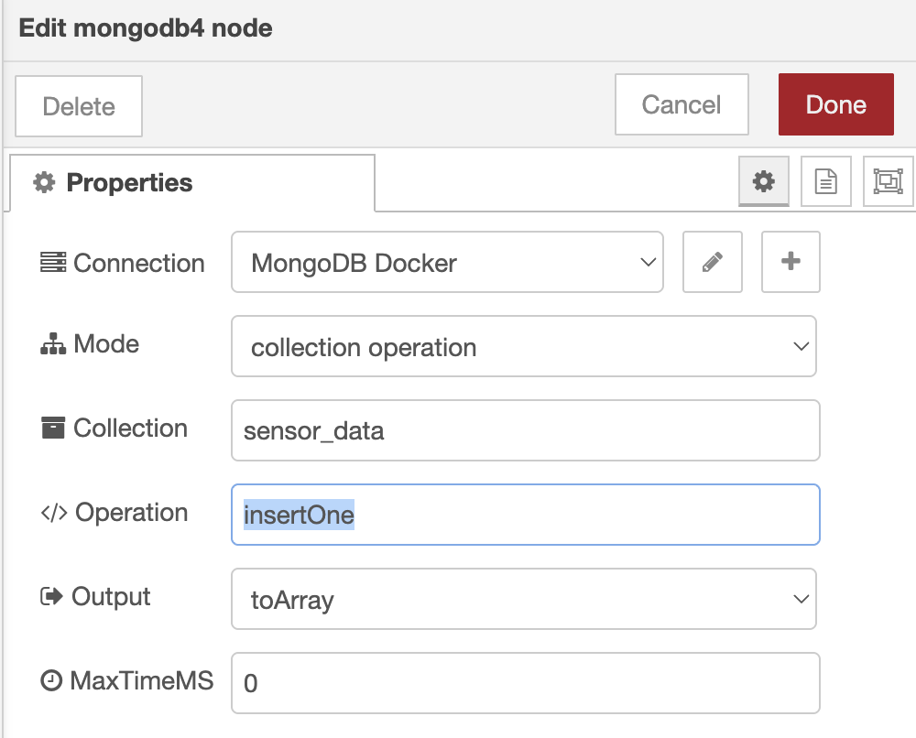

Part B: READ (HTTP GET)
- Create a new http in node set to GET /api/telemetry.
- Drag a function node onto the canvas and wire it after the GET node. Inside the function node, type:
msg.payload = [{}]; return msg; (This tells MongoDB to find everything, with no filters).
- Wire the function node to a new mongodb4 node. Set its Operation to find and check the "Output as Array" box.
- Wire the mongodb4 node to an http response node. Click Deploy.
- Test: In Postman, send a GET request to /api/telemetry. You should receive a massive JSON array containing every sensor payload you have ever inserted, automatically assigned unique _id ObjectIDs by the database!

Part C: UPDATE & DELETE (Advanced Logic)
- Update: To update a record, create an endpoint for PUT /api/sensor. Use a function node to pass an array to the database. The first element is the filter (e.g., {"device_id": "ESP_01"}), and the second is the update instruction (e.g., {"$set": {"status": "inactive"}}). Pass this to a mongodb4 node set to updateOne.
- Delete: Create an endpoint for DELETE /api/sensor. Pass a filter object from a function node (e.g., {"status": "error"}) into a mongodb4 node set to deleteMany.

Part 5: Discussion & Architectural Analysis
Based on your execution of the CRUD operations, answer the following system design questions:

Question 1: Dynamic Schema Generation
When you executed the POST request in Step 4A, you did not have to write a complex SQL CREATE TABLE query beforehand to define columns for "temperature" or "humidity". Explain the concept of a "Schema-less" database. Why is this specific feature highly beneficial during the early prototyping phases of an IoT network where sensor data formats might frequently change?

Question 2: Middleware Abstraction
In this architecture, your ESP32 (simulated by Postman) never talks directly to the MongoDB database. It only talks to Node-RED via HTTP endpoints, and Node-RED handles the database queries. Defend this architecture. Why is it a massive security risk to expose port 27017 directly to the public internet so that edge sensors can write directly to the database?

Result:

